Hate Speech Detection in Tweets using Machine Learning Models
Pardeep Kumar
Mentor: Dipanjan Sarkar
Springboard Career Science Data Track

Milestone Report 2

Capstone Project 2

Text Classification
Text classification involves assigning a class to the text document based on its overall content. In machine learning, a text document is either considered a structured sequence of tokens (character, words, long sentences) with a particular order or an entire block of input. In either case, the focus is to develop learning algorithms that can capture the semantic meaning of the words. A text document can be an article, a book, or even a single sentence. Text documents with sensitive content often require specialized skills such as categorizing whether a tweet is a racist or offensive which, sometimes gets different opinions even from the linguistic experts. With millions of text documents being generated online every day, manually labeling online text is almost impossible. Machine learning algorithms can assist in such tasks if trained on a well-labeled dataset. With developments in deep learning such as convolution neural networks, recurrent neural networks, and hybrid models, machines can perform labor-intensive jobs with fair accuracy.
In the text classification problems, the dataset consists of the documents ($di$) from some document space$(D$), labeled as one of the classes from a fixed class set,$C=\left\{c_{1},c_{2},…c_{N}\right\}$. In the supervised learning, the task of a classifier ($Ψ$) is to find a classification function ($ψ$) that can accurately map each document to the corresponding class-label, $ψ : D→C$. This report only presents one-on-one mapping, also called multiclass classification problem, where are given text input belongs to only one particular class and all classes are independent of each other. Another classification problem called multilabel text classification is one-to-many where a text document can have multiple labels. The goal of machine learning algorithms is to train a classifier on a training dataset and evaluate its performance on the test dataset (data set that the classifier has never seen before). A simple (linear) model usually result in highly biased output with underperformance on both the test and training datasets, especially when the observations have complex structures. On the other hand, sophisticated machine learning algorithms can overfit, i.e., achieve higher accuracy on the training set but underperform on test datasets. Overfitting hinders the generalization ability of the neural networks.
Performance measures based on the confusion matrix, such as accuracy, precision, F1-score, and area under the ROC curve are used to compare two classifiers. Model accuracy score is the standard performance measures in statistics. In the multiclass classification with imbalanced class distribution, relying solely on the accuracy score could lead to an inferior model selection. For examples, an always-spam classifier would be 95% percent accurate on a training set with 5% non-spam class frequency. For binary classifications, a confusion matrix compares the count of actual labels and predicted labels. For example, consider a binary text classification problem of assigning either offensive (1) and the neutral class (0) to a text document. Figure 1.1 shows a confusion matrix for the binary text classification problem, and Table 1.1 lists the four standard performance measures. Note that depending on the task, the invariance of the performance measure may be beneficial or detrimental. A performance measure is invariant if changes in the confusion matrix have no impact on its value. There are two categories of performance measures in case of the multiclass classification problems: micro-averaging which sums the count of confusion matrix components to obtain the cumulative values or macro-averaging which computes a simple average over all classes. A micro-averaged metric is the measure of effectiveness on broad categories, whereas macro-averaged values give a sense of efficacy on individual levels.
Figure 1.1 Confusion matrix for binary classification
Table 1.1 Performance measures for binary classification
Accuracy | $$\frac{TP+TN}{TP+FP+FN+TN}$$ | Accuracy score measures the overall effectiveness of a classifier and is most effective when the class size is relatively balanced, i.e., each class has a frequency of at least 10% occurrence.
Precision | $$\frac{TP}{TP+FP}$$ | The precision score measures the exactness of the classifier. Precision is high if the number of true positives is high, and false positives are low.
Recall (Sensitivity) | $$\frac{TP}{TP+FN}$$ | Recall measures the completeness or sensitivity of the classifier. High recall means that the false-negative count is low and true positives are high.
F1-Score | $$\frac{2×TP}{2×TP+FP+FN}$$ | Recall and precision are often at odds. F1-score combines the two by taking their weighted harmonic mean.

Problem Statement
The main objective of this report was to evaluate the performance of the neural networks in detecting weather a tweet is hateful, offensive, or neither, against decision tree models. Text classification is subjective, i.e., one user can find the comment offensive while it might be neutral for another individual. Due to such issues, online communication platforms such as Facebook, Twitter, often have trouble on which side to support where free speech is protected.
One obvious solution could be to mark all the tweets, comments, reviews, as hateful/offensive with a high frequency of abusive language. However, detecting profanity in the text can be challenging as the users often obfuscate the correct spellings such as a$$hole and b!! tch. A better approach would be to train a machine learning model to recognize structural patterns exhibited by the text documents belonging to a particular class.
Despite the fame and popularity, the neural networks have struggled in performance when compared with statistical models such as decisions trees. A recent empirical study [1], showed that in higher-dimensional problems, the random forest classifiers consistently outperformed the neural networks. Decision tree models require heavy preprocessing of the text data before training the classifiers. In comparison, neural networks can perform well on features with an intricate structure. Having a classifier that can perform well without too much computational cost can help curb the offensive/hateful language to appear on online platforms.
This report details the data mining, preprocessing, baseline models, and neural networks for multiclass classification of imbalance tweet dataset.

Data Exploration
A text data set is a collection of data objects, which in turn are defined by their attributes that reflect the essential characteristics of objects. The Twitter dataset had two types of attributes:
- Categorical or qualitative attributes such as the class of each tweet (hate, offensive or neutral), and
- Numeric or quantitative characteristics such as the length of each tweet.
Most machine learning tasks start with:
- Collection of the raw data, and
- Preprocessing the raw data to make for analysis.

Data Mining
The dataset was a collection of 24,784 manually labeled tweets by CrowdFlower [2] users as hate_speech, offensive_langauge, or neither [3]. Table 2.1 shows the first three rows of raw data. Out of the six columns in the table, four fields were dropped, keeping only columns labeled class and tweet.
The class field contained the majority votes a tweet received from the CrowdFlower users out of 0 – hate speech, 1 – offensive speech, and 2 – neutral (neither). As shown in Figure 2.1, the tweet count per class was highly imbalanced with 6%, 77%, and 17% tweets in the hate, offensive, and neutral class, respectively.
Table 2.1 Raw dataset for tweet classification
count | Hate speech | Offensive language | neither | class | tweet
3 | 0 | 0 | 3 | 2 | !!! RT @mayasolovely: As a woman you shouldn't complain about cleaning up your house. &amp; as a...
3 | 0 | 3 | 0 | 1 | !!!!! RT @mleew17: boy dats cold...tyga dwn bad for cuffin dat hoe in the 1st place!!
3 | 0 | 3 | 0 | 1 | !!!!!!! RT @UrKindOfBrand Dawg!!!! RT @80sbaby.
3 | 0 | 2 | 1 | 1 | !!!!!!!!! RT @C_G_Anderson: @viva_based she look like a tranny
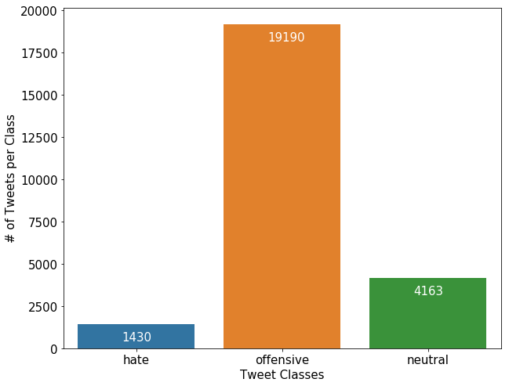
Figure 2.1. Tweet count per class

Data Preprocessing
The raw tweets were messy, especially those that belonged to the hate and offensive categories, with poor spelling, grammar, and sentence structure. Often extensive data cleaning is necessary before developing any text classifier. The raw data file was uploaded in the UTF-8 Unicode (byte per character) format preserving the unknown words that are often modified if loaded using ASCII format. The text normalization methods such as stemming or lemmatization were not part of preprocessing. It was done to study how well different classifiers can perform on the moderately processed text.
Following features were removed from the tweet during preprocessing:
- Username: Usernames were limited to a maximum length of 15 characters after ‘@' symbol.
- Web address: Web addresses started either with "https://” or directly as “www…".
- Retweet handle: Keyword 'RT' short for re-tweet.
- Punctuations: Punctuations are the most common feature in the online texts and do not convey any meaning to the machine learning classifiers.
- Emoticons: Emoji could be useful in the right context but, dropped for this study.
- Numbers: Numeric data did not add to any text classification relevance.
- Stop words: Stop words are common words with high occurrence but carry little information for the text classification tasks, e.g., words like a, an and the.
The final modification was to change all characters to lowercase. Figure 2.3 shows the character length distribution of the raw and cleaned tweets. Maximum character length in the unprocessed dataset was 754 characters exceeding the twitter limit of 140 characters (now increased to 250) because of the twitter emojis in the text. Emoticons are extremely popular in online texts, and their UTF-codes expand to long character strings in datafiles. However, for the current study, they were not included in the clean tweet texts.
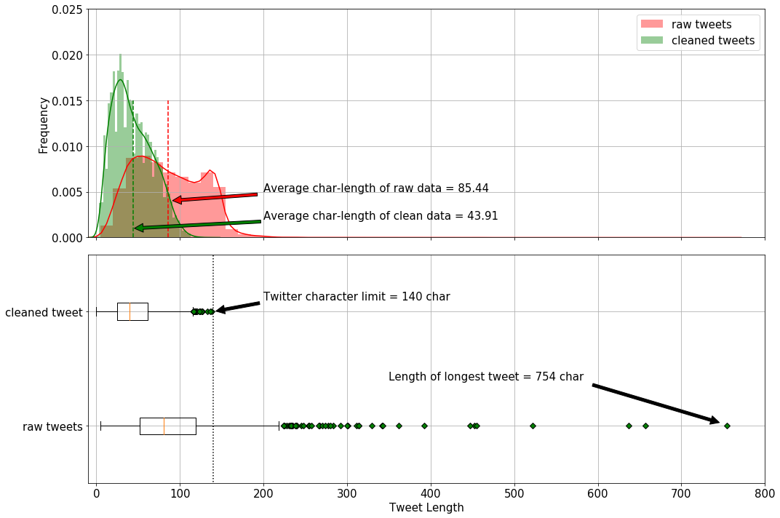
Figure 2.3 Character length comparison of raw- and clean-tweets
Table 2.2 shows the statistics of the raw- and cleaned-tweet character length. The average character length of the cleaned tweets was about 50% of the original tweets with 57% less standard deviation. Preprocessing resulted in removing the unwanted outliers from the dataset, Figure 2.3.
Table 2.2 Statistics of raw and cleaned tweets
 | count | mean | std | min | 25% | 50% | 75% | max
Raw tweet length | 24783 | 85.43 | 41.55 | 5.0 | 52.0 | 81.0 | 119.0 | 754.0
Clean tweet length | 24783 | 43.91 | 23.50 | 0 | 25.0 | 40.0 | 61.0 | 138.0

Word Vectors
Following the text data mining and preprocessing, the text data requires tokenization. Machine learning algorithms can only work with numerical inputs, and each algorithm requires data presented in a specific format. Tokenization is the process of splitting the text documents into smaller units called tokens and assign them either a unique index (a number) or a vector. Depending on the problem, tokens can be individual characters, words in the document, or N-grams. N-grams are the groups of overlapping consecutive characters or words. Most of the research in natural language processing has focused on the corpus in the English language. Without due diligence, even state-of-the-art machine learning models might underperform significantly when other languages are involved. For example, if the language contains rare vocabulary words (a word with low occurrence), the character-based tokenization might be a better representation of the input (rather than word-based).
Words that occur in similar contexts tend to have similar meanings [4] [5]. In machine learning, a word vector represents the meaning of a word. Vector similarity can be expressed using the cosine of the angle between two (unit) vectors. For two n-dimensional vectors, ${x_{i},x_{j}∈R}^{n}$, the cosine similarity is the dot product between two vectors (usually unit vectors) as,
$${Similarity}_{cosine}=\cos\left(θ\right)=\frac{x^{i}}{{\left\|x^{i}\right\|}_{2}}.\frac{x^{j}}{{\left\|x^{j}\right\|}_{2}}$$
If the words are the points in the vector space, words with similar meaning are "closer," and the magnitude of the cosine similarity measure is closer to unity. On the other hands, for the two uncorrelated (out-of-context) words, the cosine similarity measure would be smaller or close to zero. Two common vector-representations are a bag-of-words model (count or co-occurrence based) and word embedding (context-prediction based).

Bag-of-Words
Bag-of-word models hypothesize that relevance of a document to a specific query depends on the word frequency in the document [4]. Bag-of-words model represents a word (token) as a one-hot encoded vector. For example, consider a simple expression "My dog is always excited and joyful." Figure 3.1 shows the one-hot encoded representation of the words. Each word in Figure 3.1 is a 7-dimensional unit vector.
As the size of vocabulary increases, so does the length of each one-hot vector. Managing large scale sparse vectors (matrices) can be computationally expensive and often impossible. Also, the bag-of-word vectorization technique is not order-preserving, and the meaningful structure of the sentence is lost when transformed into one-hot vectors. In Figure 3.1, the words ‘excited’ and ‘joyful’ are similar in context but have zero cosine similarity, which would affect the ability of an algorithm to learn the correct document context.

Figure 3.1. One-hot encoding
Figure 3.1 is a simple example where each word occurs only once in the text (document). Large documents comprise of hundreds of words repeated multiple time. For example, the word occurs in the context of almost every noun and has high word-frequency. One approach is to replace the indicator (0,1) for word occurrence with the (0, word count). Another approach is to create a co-occurrence matrix. Co-occurrence matrix counts the number of times (frequency) a word appears in a document with other words in the corpus. For larger document space, term-document matrix, where each entry is the count of the target word in different documents, is more informative than the (word-word) co-occurrence matrix.
Stop words (e.g., a the, of) occur more frequently in the documents and cause skewness in the co-occurrence matrix without adding any relevant information. On the one hand, the count of more frequently co-occurring words is crucial, and on the other hand, words that are more frequent lack of any useful information. TF-IDF algorithm can balance the two paradox to obtain an updated new-matrix. Each entry in the updated matrix is the product of the term-frequency and the inverse document frequency,
$$C_{t,d}^{updated}={tf}_{t,d}×{idf}_{t,d}$$
Term frequency is obtained by logarithmic transformation (base 10) of the entries of the co-occurrence matrix of a given document ($C_{t,d}$), such that words that occur more frequently receive a higher penalty.
$${tf}_{t,d}=\left\{\begin{matrix}1+\log_{10}{C_{t,d}}, if C_{t,d}>0 \\ 0 otherwise\end{matrix}\right.$$
The inverse document frequency ($idf$) assign relative importance to more discriminative words, words that might appear more often in one document but sparsely in the rest of the text-corpus. A large document set is also log-transformed to bound the computed values,
$${idf}_{t,d}=\log_{10}\left(\frac{size of text corpus}{ number of documents the term t occurs }\right)$$
TF-IDF vector model can capture similarities between words as they focus heavily on target-context word occurrence. However, the issue of large vector (matrix) size remains a challenge as online text data usually has a large vocabulary. The idea of TF-IDF valid for both the character and word N-grams.

Word Embedding
A straightforward way to avoid long sparse vectors is to map them onto a smaller dimension. The dense representation of sparse word vector is called word embedding. A one-hot vector is trained on a single hidden layer neural network, and the weights of the layers correspond to the dense representation of the word. Each word in the vocabulary is assigned a target and context vector, and the neural network is trained such that similar words have a high value of the similarity measure.
Word embedding can be included in the model either by extracting vocabulary from the training data and (specific to a problem) or by using the pre-trained word embedding. In either case, each word in the dataset is assigned an index and embedding layer maps the index to a dense vector. There are two primary pre-trained word-embedding databases: Word2Vec and GloVe.

Word2Vec
Word2vec is an efficient way of local context-based learning and has been quite useful in the text classifications using deep learning [7]. Word2Vec method yields an embedding layer, which is the input to the classifier. Two main algorithms for getting the word embedding in Word2vec are:
1) Continuous skip-gram model: Given a target word, the continuous skip-gram model learns the vector representation of the context words. A binary classifier is trained to predict the likelihood of a word occurring in the neighborhood of the target word.
2) Continuous bag-of-word model. The continuous bag-of-words model learns the dense vector representation of a target word from the given context.

GloVe
Word2Vec are predictive models of vector representation that focus on minimizing the loss in predicting the target words from the context words. Global Vector Word Representations (GloVe) are count-based models that learn by dimensionality reduction on the global (from large corpus) word-word co-occurrence matrix (frequency of the target words co-occurring with the context words). The large co-occurrence matrix is normalized, log-smoothed, and the factorized to obtain a lower-dimensional matrix. Factorization is done such that the higher-dimensional data variance is well explained by the lower-dimensional matrix [8]. Performance of NLP models using pre-trained word-vector representations based on, either Word2Vec or GloVe corpus has been comparable [9].
For this study, 300-dimensional pre-trained GloVe model was used for the vector representations of the tweets and the tokens [8]. The neural network classifiers were trained on the same training set, and the best model was selected based on the test set performance.
Figure 3.2 shows the distribution of word-counts per tweet using strip and violin plots. The maximum length of tweets in the training set was 26 words (far right green zone), and the median and average word count was 5 and 7, respectively. Note that the plot is based on the training set vocabulary.
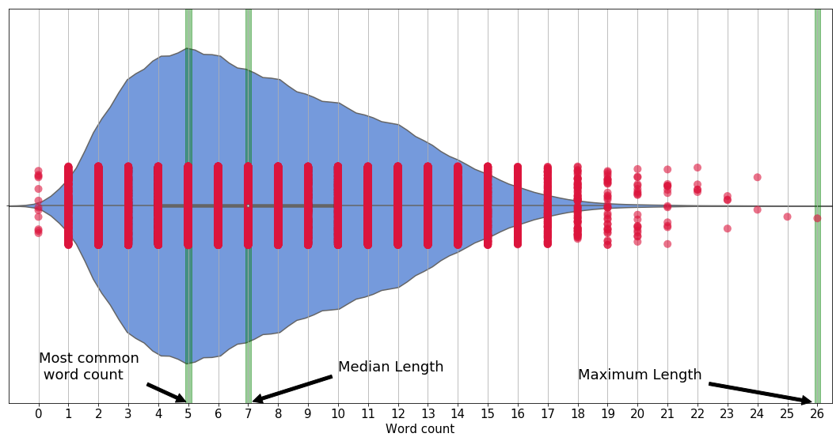
Figure 3.2. Tweet length (word count)

Baseline models
A famous aphorism in statistical learning is "all models are wrong, but some are useful'. Thus, a model can only be evaluated relative terms to another due to lack of an absolute measure in statistics. A baseline model serves as a benchmark against which the performance of other classifiers can be compared. Characteristics such as simple execution and interpretation usually decide a baseline model.
In the text classification problems, the dataset consists of the documents ($di$) from some document space$(D$), labeled as one of the classes from a fixed class set,$C=\left\{c_{1},c_{2},…c_{N}\right\}$. In the supervised learning, the task of a classifier ($Ψ$) is to find a classification function ($ψ$) that can accurately map each document to the corresponding class-label, $ψ : D→C$. This report only presents one-on-one mapping, also called multiclass classification problem, where are given text input belongs to only one particular class and all classes are independent of each other.
The goal of machine learning algorithms is to train a classifier on a training dataset and evaluate its performance on the test dataset (data set that the classifier has never seen before). Figure 4.1 shows the histogram with individual category counts in the training and test data set. The category class hate, offensive and neutral were assigned class labels of 0, 1 and 2, respectively. The relative distribution (class ratios) of tweets in the training and test datasets was almost the same. Baseline models in this report were trained on the word vectorized using the TF-IDF algorithm.
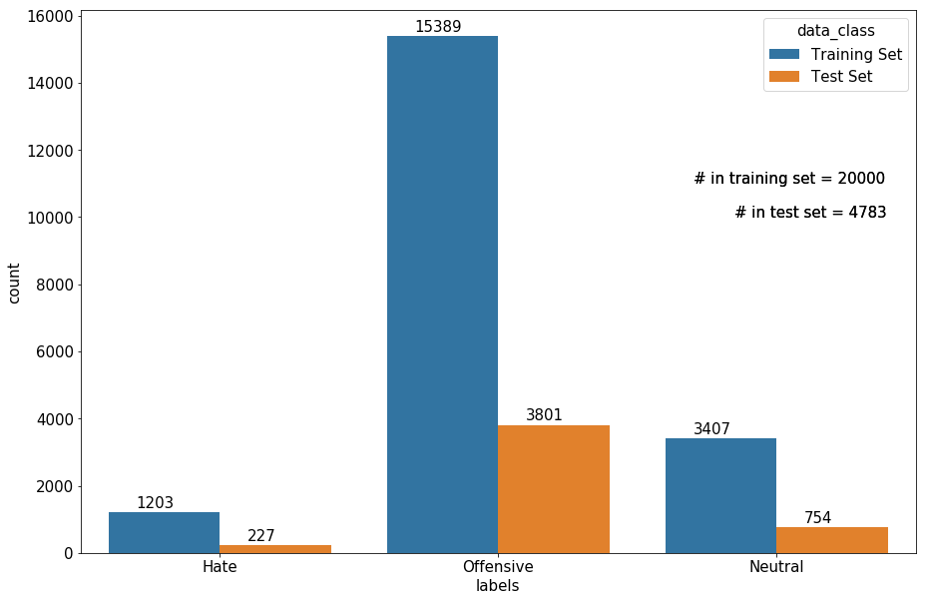
Figure 4.1 Tweet count (per class) in training and test set

Majority Class Baseline Model
In an imbalanced class dataset, the Majority Class Baseline (MCB) model, identifies the dominant class is the training data set and assigns that class as the prediction to every input in the test set. MCB models are simple, fast to execute and are used in practice when state-of-the-art models are unavailable (e.g., naïve prediction models in time series analysis).

Performance Measures
MCB model provided a baseline worst-case scenario where the predictions were guessed based on labels rather than the features of the text. The offensive class was dominant in the training set and was selected as the model prediction for any input. Figure 4.2 shows the multiclass confusion matrix computed for the test dataset. As expected, the accuracy of MCB model for the offensive class was 100% and zeroed for the other two classes. The submatrices in Figure 4.3 were computed by reducing the multiclass classification problem to a simple binary classification, where tweet either belongs to a particular class or not. For example, the first submatrix was for the binary classification of tweets either in hate class or not-hate (either offensive or neutral). MCB model labeled all tweets as offensive (not hate category); thus, the model correctly identifies true negative, i.e., the 4,556 not-hate tweets (3801 in offensive and 755 in neutral class) were correctly labeled. Since none of the tweets were labeled hate, the number of true positives and false positives were zero. Total of 227 of tweets in hate class were labeled as offensive tweets.
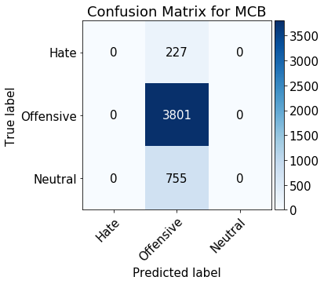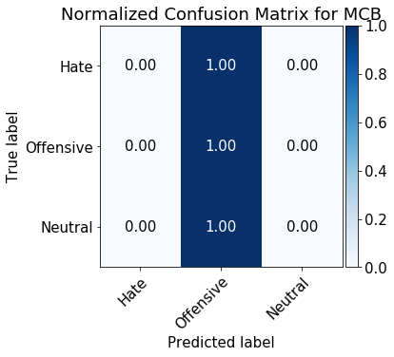
Figure 4.2 Confusion matrix for MCB Model
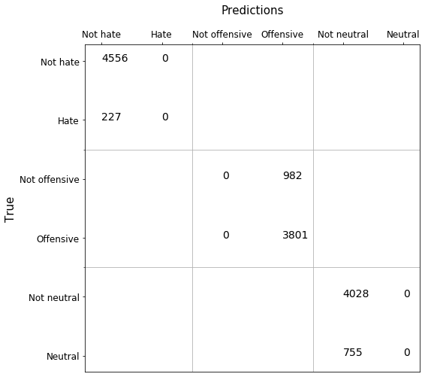
Figure 4.3 Multiclass confusion sub-matrix for test data

Accuracy
The average accuracy represented the effectiveness of each classifier average over the total number of classes. For the balanced dataset, accuracy represents the overall effectiveness of the classifier. The average accuracy of test predictions was computed as below:
$${Accuracy}_{average}^{test}= \frac{1}{3}\sum_{class=0}^{2}{\left(\frac{{TP}_{class}+{TN}_{class}}{{TP}_{class}+{TN}_{class}+{FP}_{class}+{FN}_{class}}\right)}$$
$${Accuracy}_{average}^{test}= \frac{1}{3}\left(\frac{0+4556}{0+4556+0+227}+\frac{3801+0}{3801+0+982+0}+\frac{0+4028}{0+4028+0+755}\right)$$
$${Accuracy}_{average}^{test}= \frac{1}{3}\left(0.95+0.79+0.84\right)=0.86$$
Thus, the MCB model was 86% accurate rather high number. Thus. The model accuracy was not a reliable performance measure in the case of imbalanced classes (section 2.1).

Precision
Precision represents the agreement between the classifier and the dataset on the actual class labels. Micro precision represents the classifier and class label agreement by cumulating the per-class results. Macro precision is the average agreement between the classes and the classifier.
In case of MCB predictions, both the numerator $\left({TP}_{class}\right)$ and the denominator $\left({TP}_{class}+{FP}_{class}\right)$ were zero for tweets in hate (class label 0) and neutral (class label 2) categories, as all cases were predicted to be negative (other class - offensive) for these two classes.
$${Precision}_{micro}^{test}=\frac{\sum_{class=0}^{2}{{TP}_{class}}}{\sum_{class=0}^{2}{\left({TP}_{class}+{FP}_{class}\right)}}=\frac{0+3801+0}{\left(0+0\right)+\left(3801+982\right)+\left(0+0\right)}=0.79$$
$${Precision}_{macro}^{test}= \frac{1}{3}\sum_{class=0}^{2}{\left(\frac{{TP}_{class}}{{TP}_{class}+{FP}_{class}}\right)}\frac{1}{3}\left(N/A+\frac{3801}{3801+982}+N/A\right)=0.26$$

Recall
Recall, also called sensitivity, defines a classifiers effectiveness in identifying positive labels. Recall is number of correct predictions divided by number of predictions that should be correct.
Recall for the hate and neutral categories was zero as none of the classes were identified as positive labels by the MCB classifier. This impacted the macro recall where only non-zero term was for the offensive class.
$${Recall}_{micro}^{test}=\frac{\sum_{class=0}^{2}{{TP}_{class}}}{\sum_{class=0}^{2}{\left({TP}_{class}+{FN}_{class}\right)}}=\frac{0+3801+0}{\left(0+227\right)+\left(3801+0\right)+\left(0+722\right)}=0.79$$
$${Recall}_{macro}^{test}= \frac{1}{3}\sum_{class=0}^{2}{\left(\frac{{TP}_{class}}{{TP}_{class}+{FN}_{class}}\right)}= \frac{1}{3}\left(\frac{0}{0+227}+\frac{3801}{3801+0}+\frac{0}{0+722}\right)=0.33$$

F1-Score
F1-score represents the relation between the positive labels of data and classifiers. F1-score is a harmonic mean of performance and recall. F1-score is one of the most common performance measures used to compare models especially in the case of imbalanced datasets. Micro F1-score of test predictions was same was micro-and micro-recall.
$${F1-score}_{micro}^{test}=\frac{2×{Precision}_{micro}^{test}×{Recall}_{micro}^{test}}{\left({Precision}_{micro}^{test}+{Recall}_{micro}^{test}\right)}=\frac{2×0.79×0.79}{\left(0.79+0.79\right)}=0.79$$
$${F1-score}_{macro}^{test}=\frac{2×{Precision}_{macro}^{test}×{Recall}_{macro}^{test}}{\left({Precision}_{macro}^{test}+{Recall}_{macro}^{test}\right)}=\frac{2×0.26×0.33}{\left(0.26+0.33\right)}=0.29$$

AUC
The area under the ROC curve (AUC) represents a model's ability to avoid incorrect classifications. A perfect predictor will have AUC of unity. MCB model classifier had micro-average AUC of 0.50, which was same as making a random guess prediction.
$${AUC}_{micro}^{test}=\frac{1}{2}\left(\frac{\sum_{class=0}^{2}{\left({TP}_{class}\right)}}{\sum_{class=0}^{2}{\left({TP}_{class}+{FN}_{class}\right)}}+\frac{\sum_{class=0}^{2}{\left({TN}_{class}\right)}}{\sum_{class=0}^{2}{\left({TN}_{class}+{FP}_{class}\right)}}\right)$$
$${AUC}_{micro}^{test}=\frac{1}{2}\left(\frac{0+3801+0}{\left(0+227\right)+\left(3801+0\right)+\left(0+755\right)}+\frac{4556+0+4028}{\left(4556+0\right)+\left(0+982\right)+\left(4028+0\right)}\right)$$
$${AUC}_{micro}^{test}=\frac{1}{2}\left(0.795+0.897\right)=0.85$$
$${AUC}_{macro}^{test}=\frac{1}{3}\sum_{class=0}^{2}{\frac{1}{2}\left(\frac{{TP}_{class}}{{TP}_{class}+{FN}_{class}}+\frac{{TN}_{class}}{{TN}_{class}+{FP}_{class}}\right)}$$
$${AUC}_{macro}^{test}=\frac{1}{3}\left[\frac{1}{2}\left(\frac{0}{0+227}+\frac{4556}{4556+0}\right)+\frac{1}{2}\left(\frac{3801}{3801+0}+\frac{0}{0+982}\right)\frac{1}{2}\left(\frac{0}{0+755}+\frac{4028}{4028+0}\right)\right]$$
$${AUC}_{macro}^{test}=\frac{1}{3}\left[\frac{1}{2}×1+\frac{1}{2}×1+\frac{1}{2}×1\right]=0.5$$

PR and ROC Curves
Figure 4.4 shows the Precision-Recall (PR) curve. For a model with perfect performance, the area under the curve for each class is 1. However, that is often the case in practice. The plot suggested that the precision-recall measure for the neutral class was worst and best for the offensive class. Impact of offensive class on the micro average precision is apparent. Figure 4.5 shows the Receiver Operating Curve (ROC) of MCB model predictions on the test data. In the case of imbalance dataset, the PR curve is more reliable than the ROC curve as the PR curve remains the same for balance and imbalanced datasets. However, the ROC curve for imbalanced data set is usually higher.

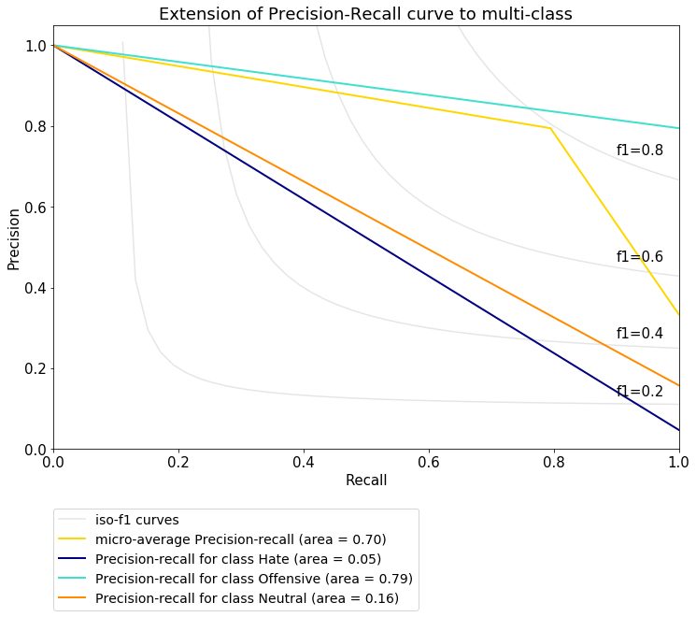
Figure 4.4 Precision-recall curve for the multiclass MCB classifier
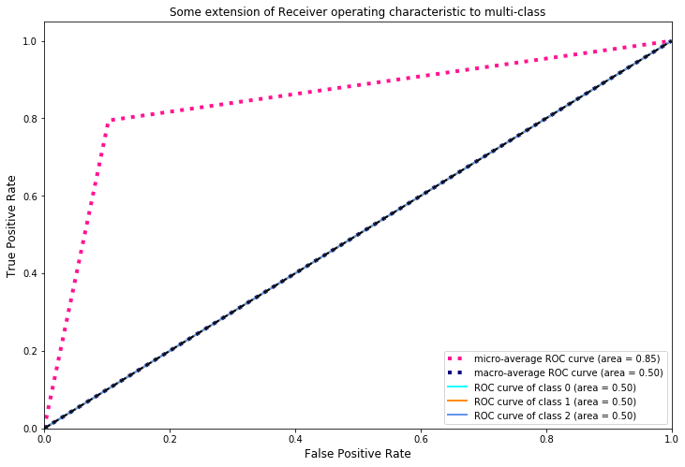
Figure 4.5 ROC curve for MCB classifier

Random Forest Classifiers
Tree-based models involve stratification of the feature space to simple regions, where an (inverted) tree is grown using splitting rules imposed on the input features at different points (called nodes). Each split-up path (called branch) leads to the final regions (called leaf nodes). Regression and classification problems can be solved using decision tree methods.
The decision tree is fit (grown) on every sentence in the document, and finally, the document is assigned the majority class (model prediction). Decision trees are intuitive and easily interpretable. Their interpretability, however, decreases for more complex problems. Decision trees can overfit, where large trees tend to fit well on the training set but perform poorly on the test set due to lack of generalization. Tree pruning can be used to control the depth of the tree and reduce the number of splits, but if the initial splits are relatively less important to the splits down the line, then tree pruning might be detrimental to the classifier.
Averaging the results of multiple, fully-grown trees on different training data sets could result in reduced variance in the output. Unlimited training sets, however, are not available in practice. Recording more observation or generating synthetic data can help solve the high variance issue. Decision trees rely on a simple, yet powerful technique called bagging for obtaining larger training dataset. From a given training dataset of size n, bagging draws random observations with replacement to generate new data sets of size n. On average, the bagged subsets contain 2/3rd of the original data. Trees are then fit on the different bagged datasets, and the majority class is the model's prediction.
Bagging is effective in reducing the variance if the resulting trees are uncorrelated. Stronger features are often selected picked first and most, resulting in similar trees on bagged datasets. Having a large number of correlated trees results in the issue of overfit remaining unresolved.
Random forests overcome this limitation by randomly selecting a subset of the input features to choose from, at each node. Random selection provides an opportunity for the not-so-strong features to be selected built different trees. Out of say F total predictors, a random subset of f predictors is selected at each node. On average, $\left(1-f⁄F\right)$ splits will not even consider the strong features for splitting decision, which results in decorrelated decision trees. Averages from decorrelated trees are less prone to overfitting, making the analysis reliable. Typically, the subset size f is approximately equal to the square root of the total number of features, i.e., $f≈\sqrt{√F}$.

TF-IDF Vector
The input tweets were first vectorized using the TF-IDF algorithm. Twitter data often contains slangs that are not included in English vocabulary or might be from a different language. Character level feature space can sometimes result in a better classification model [10]. Figure 4.6 shows the distribution of the character length of each word in the vocabulary (training set). The average and median length of vocabulary words were 6. Based on this observation, eight different N-gram features were used to evaluate the random forest classifier:
- Character level $N$-grams where $N∈\left\{2, 3, 4, 5, 6\right\}$
- Word level $N$-grams where $N∈\left\{1, 2, 3\right\}$
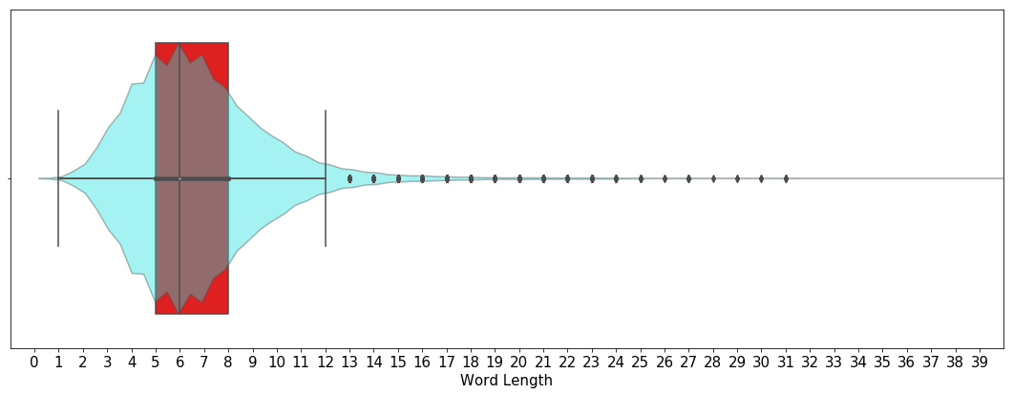
Figure 4.6 Character-length distribution of vocabulary words

Random Forests
The classifier was first tuned using 5-fold cross-validation grid search for two hyperparameters:
- Maximum number of features per split
  - $max_features = \{100,200,500\}$
- Total number of trees
  - $n_estimators =\{500,800,1000\}$
Word unigrams input features were used for the grid search. It was assumed that model performance for other features was the same. The mean validation error (0.83+0.01) and standard deviation (0.12+0.02) did not show any wide variation during the grid search. Hyperparameter values with $max_{features}=500, n_estimators$= 100 selected.
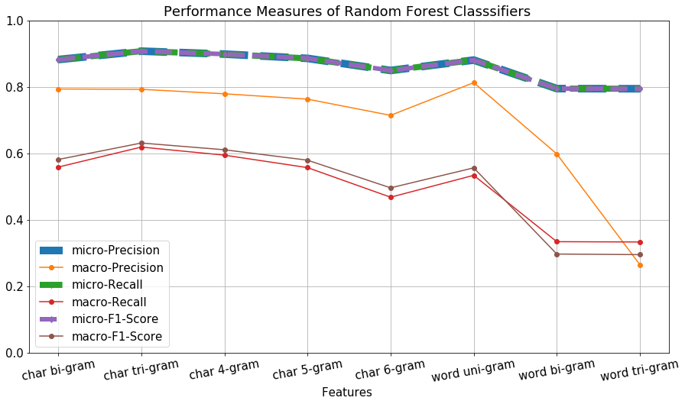
Figure 4.7 Performance measures of random forest classifiers to different features
Figure 4.7 shows different performance measures for each input feature. The micro measures were more consistent than macro-scores. Also, since the value of precision, recall, and f1-scores (micro-level) was the same per feature, micro F1-score was selected as the performance measures to compare different classifiers.
Table 4.1 and Table 4.2 lists the performance of random forest classifiers character and word level n-grams, respectively. Character level N-gram features performed better than word-level features. Overall performance of character 4-grams was highest while word trigrams had the worst values of the metrics, in line with another study [10].
Table 4.1 Performance measures of random forest classifiers with character N-grams as features
Performance Measures |  | Char Bigram | Char Trigram | Char 4-Gram | Char 5-Gram | Char 6-Gram
Micro | Precision | 0.8844 | 0.9049 | 0.9001 | 0.8850 | 0.8518
Micro | Recall | 0.8844 | 0.9049 | 0.9001 | 0.8850 | 0.8518
Micro | F1-Score | 0.8844 | 0.9049 | 0.9001 | 0.8850 | 0.8518
Macro | Precision | 0.8093 | 0.7840 | 0.7720 | 0.7387 | 0.7622
Macro | Recall | 0.5638 | 0.6130 | 0.5965 | 0.5529 | 0.4728
Macro | F1-Score | 0.5847 | 0.6248 | 0.6104 | 0.5752 | 0.5023
Table 4.2 Performance measures of random forest classifiers with word N-grams as features
Performance Measures |  | Word Unigram | Word Bigram | Word Trigram
Micro | Precision | 0.8821 | 0.7955 | 0.7949
Micro | Recall | 0.8821 | 0.7955 | 0.7949
Micro | F1-Score | 0.8821 | 0.7955 | 0.7949
Macro | Precision | 0.7586 | 0.5985 | 0.5983
Macro | Recall | 0.5341 | 0.3351 | 0.3338
Macro | F1-Score | 0.5551 | 0.2989 | 0.2961
Since the other classifiers (neural networks) were trained using word-level vectorization, word-unigram + Random Forest model was selected as the baseline model for this study. Table 4.3 shows the classification report of the final base model. Compared to the MCB model the random forests were far better. Figure 4.8 shows the PR curve for the random forest model. The area under hate class curve was less than other classes however compared to MCB model all three curves had higher PR area. Figure 4.9 shows the confsion matrix for the random forests on the test set. Compared to MCB model, random forest were able to perform better in terms of labeling the neutral and hate classes.

Table 4.3 Classification report of word unigrams + random forests
 | PR_AUC | F1-SCORE | PRECISION | RECALL
Hate | 0.3442 | 0.3543 | 0.5041 | 0.2733
Offensive | 0.9636 | 0.9441 | 0.9516 | 0.9366
Neutral | 0.8874 | 0.8339 | 0.7595 | 0.9245
Micro Avg | 0.9412 | 0.9032 | 0.9032 | 0.9032
Macro Avg | 0.7317 | 0.7108 | 0.7384 | 0.7114
Weighted Avg | 0.9222 | 0.8987 | 0.9002 | 0.9032
Samples Avg | 0.9486 | 0.9032 | 0.9032 | 0.9032
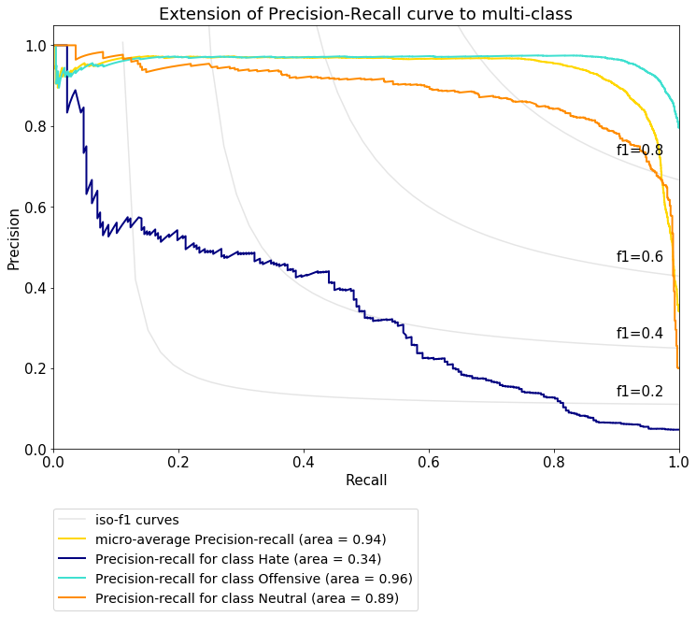
Figure 4.8 PR plot for the baseline model
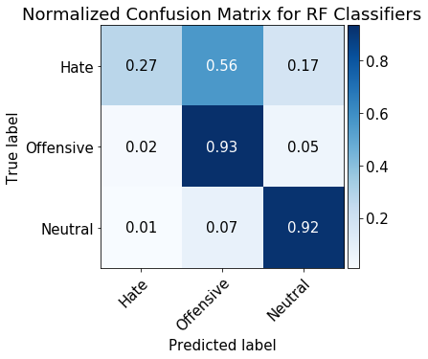
Figure 4.9 Confusion matrix for the baseline model

Neural Networks
Artificial Neural Networks (ANN) are a simplified version of the brain architect. ANN can solve both supervised and unsupervised problems. ANN comprises of various components such as nodes, weights and activation functions. Nodes form the primary connection hubs for the network. A node accepts the weighted information from other nodes and sums it up before passing it on to the activation unit. Assigned weights control the influence of a node on the nodes in the next layer. An activation unit acts as a filter for ANN, which controls the amount and type of information transferred down the pipeline. The selection of an activation function depends on the problem at hand. Nodes and activation units form the layers of an ANN (hidden layers to be specific). Assuming information is flowing from left to right, the two outermost layers are called the input layer (leftmost) and the output layer (rightmost). The number of nodes in each of these layers depends on the available data. Any layer in-between the input and output layer is called the hidden layer.
Figure 5.1 shows a
simple neural network with an input layer, one hidden layer with one neuron and one output layer. A linear combination of features, weights (and biases) is input into the neuron unit which transforms the affine function into one single values as the network output. For a binary classifier with supervised data $\left((x,y\right)∈R^{m}×R$), the one-neuron network computes the output as follows,
$$\hat{y}=f\left(w_{1}x_{1}+w_{2}x_{2}+…+w_{m}x_{m}+b\right)$$
In the above equation, $w_{i}$’s are the weights, b is the bias, and f is a non-linear activation function. The above equation represents a feed-forward network where out is generated per input. The prediction may or may not match the correct labels of the dataset. The difference between the predicted and actual values is called the network error. A neural network can be trained to reduce this error and improve performance using backpropagation.
Figure 5.1 Simple neural network

Backpropagation
Input to a neural network can be a simple vector (one training example at a time) or a matrix (batch input). Batch size of the input data, depth of the neural network, and the width of each hidden layer are three common hyperparameters often fine-tuned using k-fold, stratified, cross-validation. For multiclass classification, the final activation unit is generally a softmax function which outputs a vector (per input), $a^{L}={\hat{y}}^{i}∈R^{C}$, where C is the total number of classes. Each component of $a_{c}^{L}$ is the probability that input $x^{i}$ belongs to the class, c. The vector component with the highest probability is the final prediction of the MLP for a given input, $\arg{\max_{c}{a_{c}^{L}}}$.
Figure 5.2 MLP architecture with error computation
Figure 5.2 shows the general MLP architecture along with one extra layer added at the right end, for error computation. The layer accepts the network outputs and actual input labels and calculates an error measure ($J$). In multiclass classifications, cross-entropy loss function (also called log-loss) is a common error measure. It imposes a heavy penalty on network outputs that are significantly farther from the actual labels. For a batch size of M, the cross-entropy loss is computed as,
$$J=-\sum_{i=1}^{M}{\sum_{c=1}^{C}{y_{c}^{i}\ln{a_{c}^{L,i}}}}$$
If the actual labels are one-hot encoded, the inner summation represents the overall logarithmic-component of the network output vector ($a^{L}$). If the network predictions are correct, ${then a}_{c}^{L, i}≈1, \ln{a_{c}^{L, i}}≈0$. If the network outputs are far from the expected values, the error magnitude is immense, $a_{c}^{L, i}≈0, \ln{a_{c}^{L, i}}→-∞$ (at least in theory). Backpropagation rule distributes the final error backward, from output layer towards the input layer, adjusting all the network weights and biases during this propagation to minimize J. The weight adjustment at a given node is directly proportional to the distributed errors in its fully connected units. The weights (and biases) are updated using the gradient descent method, that follows the steepest gradient descent in the weight space $∆w_{ij}^{l}=-η\frac{∂J}{∂w_{ij}^{l}}$. The error differential during backpropagation uses the chain rule,
$$J=f^{L+1}\left(a^{L}\right) →\frac{∂J}{∂a^{L}}=\left[\begin{matrix}\frac{∂J}{∂a_{1}^{L}} & … & \frac{∂J}{∂a_{C}^{L}}\end{matrix}\right]$$
$$a^{L}=f^{L}\left(z^{L}\right)→\frac{∂J}{∂z^{L}}=\frac{∂J}{∂a^{L}}.\frac{∂a^{L}}{∂z^{L}} →z^{L}=W^{L}a^{L-1}+b^{L}=g\left(W^{L},a^{L-1},b^{L}\right)$$
$$\frac{∂J}{∂W^{L}}=\frac{∂J}{∂a^{L}}.\frac{∂a^{L}}{∂z^{L}}.\frac{∂z^{L}}{{∂W}^{L}} \& \frac{∂J}{∂b^{L}}=\frac{∂J}{∂a^{L}}.\frac{∂a^{L}}{∂z^{L}}.\frac{∂z^{L}}{{∂b}^{L}}$$
$$\frac{∂J}{∂W^{l-1}}=\frac{∂J}{∂a^{L}}.\frac{∂a^{L}}{∂z^{L}}.\frac{∂z^{L}}{{∂a}^{L-1}}.…\frac{∂a^{l-1}}{∂z^{l-1}}.\frac{∂z^{l-1}}{{∂W}^{l-1}} \& \frac{∂J}{∂b^{l-1}}=\frac{∂J}{∂a^{L}}.\frac{∂a^{L}}{∂z^{L}}.\frac{∂z^{L}}{{∂a}^{L-1}}.…\frac{∂a^{l-1}}{∂z^{l-1}}.\frac{∂z^{l-1}}{{∂b}^{l-1}}$$

Activation Functions
Activation functions are the most important part of neural network architecture and set them apart from other statistical models such as linear or logistic regression and SVM. The differential of the output of the activation unit with-respect-to the input ($\frac{∂a^{l}}{∂z^{l}}$) depends on the choice of the activation function. The differential can impact the performance and learning abilities of a neural network. These days, non-linear activation functions are the standard because of their ability to handle the complex structures in the input data. The four easily accessible activation functions in deep learning algorithms are:

Sigmoid Function
The sigmoid function is a non-linear function with all real numbers as its domain ($-∞,+∞$) and output range between (0,1). The sigmoid function compresses any real-valued input to a value between (0,1). The sigmoid function is most common in the binary classifiers with its output representing the probability distributions.
$$σ\left(x\right)=\frac{1}{1+e^{-x}}$$
Sigmoid functions are differentiable everywhere and are monotonic (non-increasing or non-decreasing over the entire domain). The first differential of the sigmoid function is,
$$σ^{'}\left(x\right)=σ\left(x\right)\left(1-σ\left(x\right)\right)$$
The simple differential computation is extremely useful during backpropagation as the sigmoid output was computed during the forward pass. The derivative of the sigmoid function is bell-shaped and is not monotonic (Figure 5.3).
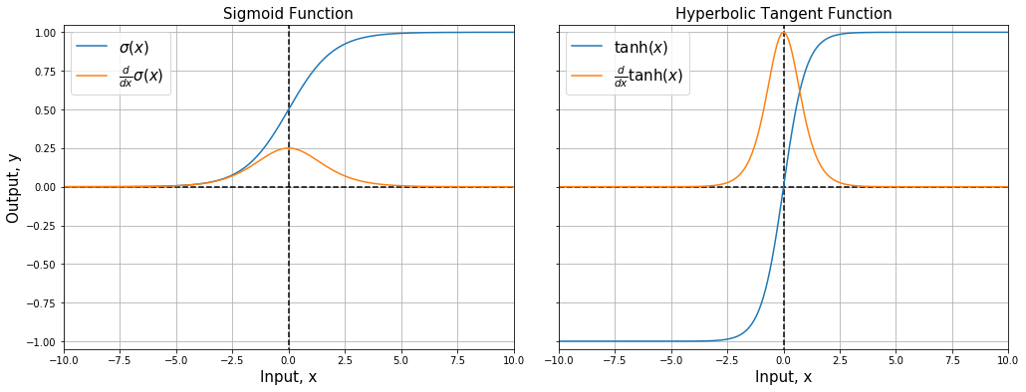
Figure 5.3 Sigmoid and hyperbolic tangent functions

Hyperbolic Tangent Function
Hyperbolic functions are similar to the sigmoid functions with real-valued inputs compressed between the range (-1, 1). The models with hyperbolic tangent functions can outperform the sigmoid activation units and are relatively easy to train. The hyperbolic functions are written as,
$$tanh\left(x\right)=\frac{e^{2x}-1}{e^{2x}+1}=2σ\left(2x\right)-1$$
The function is differentiable everywhere and monotonic with differential,
$$\tanh^{'}\left(x\right)=1-\tanh^{2}\left(x\right)$$
Compared to the sigmoid function, the hyperbolic functions are more sensitive around the neighborhood of zero. Figure 5.3 shows the plots of tanh(x) and its derivative.
Figure 5.3 also highlights the two limitations of sigmoid and hyperbolic tangent functions. Both functions can quickly saturate, i.e., as all large positive and negative values 1 and 0 (for sigmoid) or -1 (for tanh), respectively the network is unable to learn anything during the backpropagation. Both activation functions are domain-sensitive around 0.5 (for sigmoid) or 0 (for tanh), any changes around the outer domain are almost undetectable.

Rectified Linear Function
Rectified Linear function (ReL) is a non-linear function, and the neuron with ReL as its activation function is called Rectified Linear Unit (ReLU). ReLU act as a filter that only allows the positive values of input to pass through, replacing all negative values with zeros.
$$ReLU\left(x\right)=max\left(0,x\right), {ReLU}^{'}\left(x\right)=\left\{\begin{matrix}1, ∀x>0 \\ NaN, x=0 \\ 0 ∀x<0\end{matrix}\right.$$
ReLU is most used activation function neural networks. The output range of ReLU is between zero and $+∞$ , and it is non-differentiable at zero. The differential of ReLU is a simple step function making the backpropagation extremely fast.
Various modified versions of ReLU function are available, to improve the model performance, such as ReLU_{Leaky} where the negative values are in the neighborhood of but not exactly zero. ReLULeaky is preferred when a network is unable to learn from the data with a large count of negative values replaced by zeros (saturation issue). Both ReLU and ReLU_{Leaky}, along with their respective derivatives, are monotonic.
$${ReLU}_{Leaky} \left(x\right)=\left\{\begin{matrix}x ∀ x≥0 \\ ax ∀ x<0\end{matrix}\right., {ReLU}_{Leaky}^{'} \left(x\right)=\left\{\begin{matrix}1 ∀ x≥0 \\ a ∀ x<0\end{matrix}\right.$$
In the above equation, slope parameter a is usually small (0.001).
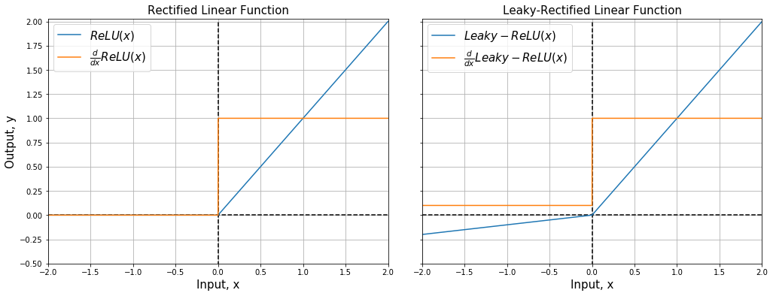
Figure 5.4 ReLU and ReLU_{Leaky}

Softmax Function
Sigmoid activation functions are mostly limited in their applications to binary tasks, and the softmax function is more appropriate for the multiclass classifier. The input vectors projected onto an exponential space and normalized. Exponentiation increases the relative distance between the input components and normalization compresses all outputs within the range 0 to 1, which is more relatable to probabilities.
$${softmax\left(x\right)}_{i}=P\left(y=i|x\right)=\frac{e^{W_{i}x}}{\sum_{c=1}^{C}{e^{W_{c}x}}}$$
In the above equation, W is the weight matrix with each row corresponding to a class, x is the input vector. The softmax function calculates the probability of given input (x) belonging to a class i ($1<i<C$). The input-output size of the softmax function is the same as the total number of classes, C. All components of the output must sum to 0.
Figure 5.5 Softmax activation function

Regularization
Neural networks tend to overfit on the training data, and therefore, multiple regularization techniques are available to make the model more reliable.
Overfitting is the ability of a machine learning model to overly adapt to the training data resulting in poor performance during the test phase. An overfitted model would have low training error but high-test error and lacks generalization. Regularization methods in neural networks penalized the weight matrices. Three extensively employed regularization-techniques in this study were:

Dropout
Dropout layers randomly select and delete a fraction of neurons from the system, along with all incoming and outgoing connections to them. The dropout fraction is a hyperparameter referred to as the dropout layer parameter.
Figure 5.6 Before and after dropout layer

Kernel Regularization
Kernel regularization penalizes the weight matrices by including them in the loss function calculation. Loss functions represent the overall model fit and are modified as follows,
$$J_{new}= J+{λ×\left\|w\right\|}_{norm}$$
The two norms used for regularization are L1 and L2-norm. L1 regularization penalizes the absolute values of the weight, whereas the L2 criterion penalizes the sum-of-squares. L2-norms can learn intricate patterns in the data compared to L1-norm. However, L1-norm is interpretable and straightforward. Both norms include multiplication with the regularization parameter ($λ$), which controls the extent of penalization.
$$J_{new}=\left\{\begin{matrix}J+λ\sum{\left|w_{i}\right|}→L_{1}-norm \\ J+λ\sum{w_{i}^{2}}→L_{2}-norm\end{matrix}\right.$$

Validation Sets
In neural networks, early stopping is included with the validation score to guide how much to train the model. In this study, early stopping with two parameters was used: monitor and patience. Validation loss was used as the monitor to track network performance per epoch. The patience parameter was used to wait out any local features impacting the validation loss. If validation loss did not show any reduction over three consecutive runs, the model execution was interrupted, and the model fit with minimum validation loss was the best model. The twitter training dataset further split into training and validation set in ratio 3:1 (Figure 5.7).
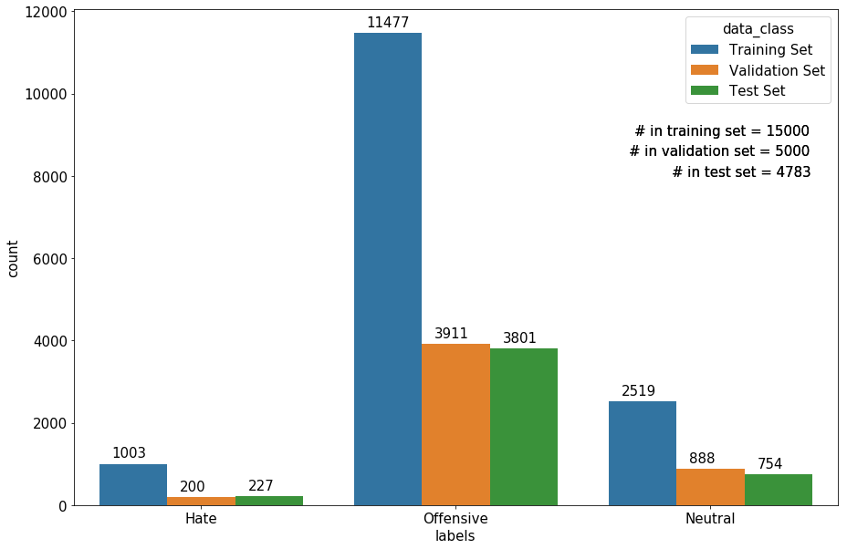
Figure 5.7 Training-validation-test split of twitter dataset

Embedding layer
For uniform inputs, the tweet texts were zero-padded near the right end (post, zero-padding). Zero-padding is vital in deep learning algorithms where the length of the input layer must be predefined. Figure 5.8 shows an example of zero-paddings. Assume ${\left(i-1\right)}^{th},i^{th} , and the {\left( i-1\right)}^{th}$ tweet has a word count of 24, 26, and 2. For a uniform input (size-wise), 2 and 24 zeros can be added to the right of the last words of ${\left(i-1\right)}^{th}$ and ${\left(i+1\right)}^{th}$ tweet, respectively.
After tokenization, each unique word was assigned an index starting with 1 (index 0 reserved for zero-paddings). The training dataset had a vocabulary size of 18, 498 words.
The 300-dimensional (pre-trained) GloVe data had about 400,000 unique words and a unique vector for each word. An empty embedding matrix (18,498 x 300) was intialized. Each word from the training set was queried against the GloVe vocabulary, and corresponding dense vectors were stored in the embedding matrix. For words with no match in GloVe corpus were initialized with zero vectors. Figure 5.9 shows a simple example with the vocabulary size of 8 and the steps to obtain the corresponding embedding matrix. For the tweet classification task, the word embeddings were stored in an embedding matrix and saved in ‘GloVe_matrix.pkl’ file and loaded right before training the different neural network model, as shown in Code Section 5.1.
Code Section 5.1 Word embedding data
embeddings_index = dict()
f = open('../wordemb/helper/glove/glove.6B.300d.txt')
for line in f:
values = line.split()
word = values[0]
coeff = np.asarray(values[1:], dtype = 'float32')
embeddings_index[word] = coeff
f.close()
print('Loaded %s word vectors.' % len(embeddings_index))

embedding_matrix = np.zeros((vocab_size, 300))
for word, i in tokenizer.word_index.items():
embedding_vector = embeddings_index.get(word)
if embedding_vector is not None:
embedding_matrix[i] = embedding_vector

embed_df = pd.DataFrame(embedding_matrix)
embed_df.to_pickle("GloVe_matrix.pkl")
Figure 5.8 Zero-paddings
Figure 5.9 Word Embedding

Multilayer perceptron
A multilayer perceptron (MLP) is the combination of multiple neurons distributed (arranged) in multiple hidden layers with each layer containing at least one neuron. All computations in MLP are done sequentially without any cyclic information exchange system such as the recurrent neural networks (discussed later in the report). This non-cyclic graph of sequential operations is called the feed-forward neural network. Figure 6.1 shows a sample MLP with depth (number of layers) equal to 4 and width of each layer is 3 (input layer), 2 (first hidden layer), 4 (second hidden layer) and 2 (output layer). Each neuron unit is fully connected with all the neurons from previous layers, called a dense connection. Note that the activation functions may vary from one hidden layer to another ($f^{l}$) but are kept the same in a given layer. Rest of the details are the same as the neural networks discussed in Chapter 5. The computations in the graph (Figure 6.1) can also be expressed in vector-matrix notations,
$$\left\{\begin{matrix}z_{1}^{1} \\ z_{2}^{1}\end{matrix}\right\}=\left[\begin{matrix}w_{11}^{1} & w_{12}^{1} & w_{13}^{1} \\ w_{21}^{1} & w_{22}^{1} & w_{23}^{1}\end{matrix}\right]\left\{\begin{matrix}x_{1} \\ x_{2} \\ x_{3}\end{matrix}\right\}+\left\{\begin{matrix}b_{1}^{1} \\ b_{2}^{1}\end{matrix}\right\} → \left\{\begin{matrix}a_{1}^{1} \\ a_{2}^{1}\end{matrix}\right\}=\left\{\begin{matrix}f^{1}\left(z_{1}^{1}\right) \\ f^{1}\left(z_{2}^{1}\right)\end{matrix}\right\}$$
$$\left\{\begin{matrix}\begin{matrix}z_{1}^{2} \\ z_{2}^{2}\end{matrix} \\ \begin{matrix}z_{3}^{2} \\ z_{4}^{2}\end{matrix}\end{matrix}\right\}=\left[\begin{matrix}\begin{matrix}w_{11}^{2} & w_{12}^{2} \\ w_{21}^{2} & w_{22}^{2}\end{matrix} \\ \begin{matrix}w_{31}^{2} & w_{32}^{2} \\ w_{41}^{2} & w_{42}^{2}\end{matrix}\end{matrix}\right]\left\{\begin{matrix}a_{1}^{1} \\ a_{2}^{1}\end{matrix}\right\}+\left\{\begin{matrix}\begin{matrix}b_{1}^{2} \\ b_{2}^{2}\end{matrix} \\ \begin{matrix}b_{3}^{2} \\ b_{4}^{2}\end{matrix}\end{matrix}\right\} → \left\{\begin{matrix}\begin{matrix}a_{1}^{2} \\ a_{2}^{2}\end{matrix} \\ \begin{matrix}a_{3}^{2} \\ a_{4}^{2}\end{matrix}\end{matrix}\right\}=\left\{\begin{matrix}\begin{matrix}f^{2}\left(z_{1}^{2}\right) \\ f^{2}\left(z_{2}^{2}\right)\end{matrix} \\ \begin{matrix}f^{2}\left(z_{3}^{2}\right) \\ f^{2}\left(z_{4}^{2}\right)\end{matrix}\end{matrix}\right\}$$
$$\left\{\begin{matrix}z_{1}^{3} \\ z_{2}^{3}\end{matrix}\right\}=\left[\begin{matrix}\begin{matrix}w_{11}^{3} & w_{12}^{3} \\ w_{21}^{3} & w_{22}^{3}\end{matrix} & \begin{matrix}w_{13}^{3} & w_{14}^{3} \\ w_{23}^{3} & w_{24}^{3}\end{matrix}\end{matrix}\right]\left\{\begin{matrix}\begin{matrix}a_{1}^{2} \\ a_{2}^{2}\end{matrix} \\ \begin{matrix}a_{3}^{2} \\ a_{4}^{2}\end{matrix}\end{matrix}\right\}+\left\{\begin{matrix}b_{1}^{3} \\ b_{2}^{3}\end{matrix}\right\} → \left\{\begin{matrix}a_{1}^{3} \\ a_{2}^{3}\end{matrix}\right\}=\left\{\begin{matrix}f^{3}\left(z_{1}^{3}\right) \\ f^{3}\left(z_{2}^{3}\right)\end{matrix}\right\}=\left\{\begin{matrix}{\hat{y}}_{1} \\ {\hat{y}}_{2}\end{matrix}\right\}$$
Figure 6.1 Multilayer perceptron with two hidden layers

Tweet Classification using MLP
Figure 6.4 and Code Section 6.1shows the training and validation set accuracy of the 1D covnet fit per epoch. At second epoch, minimum validation (45%) and corresponding validation accuracy of about 90% was observed. After ^{second} epoch, the model started to overfit on the training data.
Figure 6.5 shows the final MLP architecture selected for the tweet classification with model fit and performance details in Code Section 6.2. The neural network had five hidden layers all densely connected. MLP model slightly underperformed than the baseline model in term of performance measures, Table 6.1. The F1- score of the MLP model was about 1.8% less than the random forests. The micro average precision score of MLP model was about 1% more than the baseline model (Figure 6.6). Figure 6.7 shows the confusion matrix of MLP predictions versus the true class labels. In terms of identifying the correct class, MLP model performed better than the random forests in classifying tweets in the hate and offensive category, but random forest model was more effective in correctly identifying the neutral class. Out of the two models based on the confusion matrix, MLP model was better as it is crucial to identify the negative speech than the neutral speech correctly.
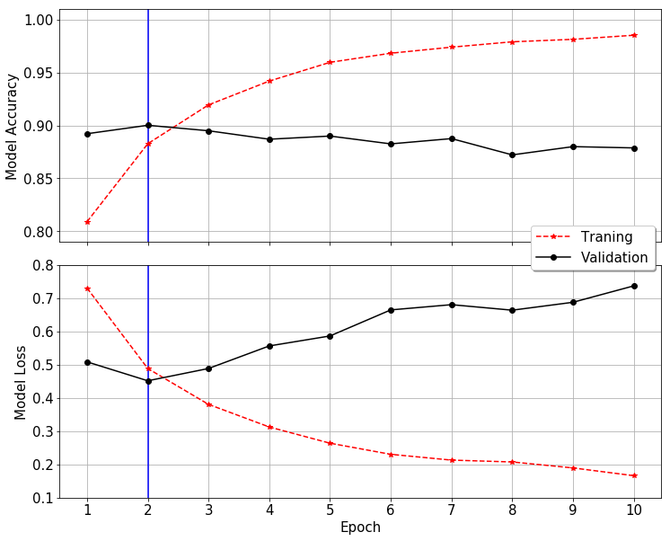
Figure 6.4 MLP model training and validation scores

Code Section 6.1 Fitting MLP model on training and validation data
Train on 15000 samples, validate on 5000 samples
Epoch 1/10
- 10s - loss: 0.7308 - acc: 0.8089 - val_loss: 0.5087 - val_acc: 0.8922
Epoch 2/10
- 10s - loss: 0.4887 - acc: 0.8827 - val_loss: 0.4518 - val_acc: 0.9002
Epoch 3/10
- 10s - loss: 0.3808 - acc: 0.9195 - val_loss: 0.4888 - val_acc: 0.8950
Epoch 4/10
- 10s - loss: 0.3127 - acc: 0.9420 - val_loss: 0.5566 - val_acc: 0.8870
Epoch 5/10
- 10s - loss: 0.2639 - acc: 0.9597 - val_loss: 0.5866 - val_acc: 0.8900
Epoch 6/10
- 10s - loss: 0.2305 - acc: 0.9683 - val_loss: 0.6650 - val_acc: 0.8826
Epoch 7/10
- 10s - loss: 0.2131 - acc: 0.9741 - val_loss: 0.6808 - val_acc: 0.8876
Epoch 8/10
- 10s - loss: 0.2075 - acc: 0.9791 - val_loss: 0.6642 - val_acc: 0.8722
Epoch 9/10
- 10s - loss: 0.1896 - acc: 0.9815 - val_loss: 0.6880 - val_acc: 0.8800
Epoch 10/10
- 9s - loss: 0.1662 - acc: 0.9853 - val_loss: 0.7373 - val_acc: 0.8788
Code Section 6.2 MLP model summary
Layer (type) Output Shape Param #
=================================================================
embedding_1 (Embedding) (None, 26, 300) 5549400
_________________________________________________________________
flatten_1 (Flatten) (None, 7800) 0
_________________________________________________________________
dense_1 (Dense) (None, 100) 780100
_________________________________________________________________
dropout_1 (Dropout) (None, 100) 0
_________________________________________________________________
dense_2 (Dense) (None, 50) 5050
_________________________________________________________________
dense_3 (Dense) (None, 25) 1275
_________________________________________________________________
dense_4 (Dense) (None, 3) 78
=================================================================
Total params: 6,335,903
Trainable params: 6,335,903
Non-trainable params: 0

Table 6.1 Classification report of multilayer perceptron
 | PR_AUC | F1-SCORE | PRECISION | RECALL
Hate | 0.2892 | 0.3416 | 0.3898 | 0.3040
Offensive | 0.9735 | 0.9357 | 0.9247 | 0.9469
Neutral | 0.8618 | 0.7828 | 0.8053 | 0.7616
Micro Avg | 0.9461 | 0.8871 | 0.8871 | 0.8871
Macro Avg | 0.7082 | 0.6867 | 0.7066 | 0.6708
Weighted Avg | 0.9234 | 0.8833 | 0.8805 | 0.8871
Samples Avg | 0.9395 | 0.8871 | 0.8871 | 0.8871

Figure 6.5 Final MLP architecture
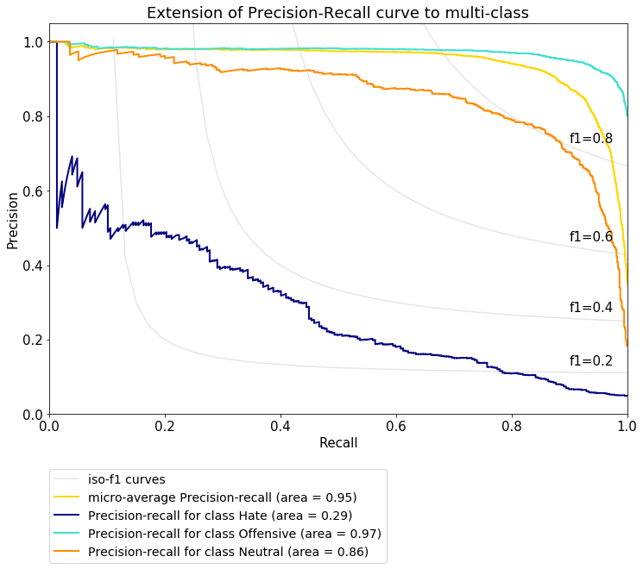
Figure 6.6 Precision-Recall Curve for MLP Model
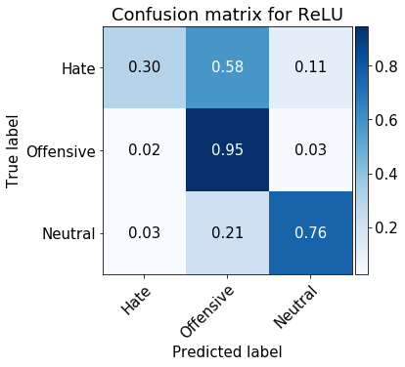
Figure 6.7 Confusion matrix of MLP predictions versus true class labels

Convolution Neural Networks
Initially developed for computer vision tasks like image classifications, Convolution Neural Networks (CNNs) have been successful in natural language processing. CNN's are incredibly versatile in handling higher-order tensors (color images are third-order tensor). In language processing, the inputs are word vectors, one-hot encoded, or dense representations.
Convolution is a mathematical operation on two functions to produce a third function that expresses how the shape of one is modified by interacting with the other function [11]. An input $x^{k}∈R^{M^{k}×N^{k}}$ to a convolution layer $f^{k}∈R^{M×N×F}$ would results in an output tensor $x^{k+1}∈R^{M^{k+1}×N^{k+1}×F^{k+1}}$. The convolution layer is projected on top of the part of the input matrix. The convolution includes element-wise multiplication followed by their addition to produce a single number (a component of $x^{k+1}$). A bias is added to the output. In the next step, the kernel strides to the right along the row (or downwards along the column).
Figure 7.1 shows the convolution process with stride-values of 1. When the stride is 1, the model convolves on every single spatial location of the input. If the convolution stride set to 2 (>1), the kernel would skip 1 (s-1) pixels in the next step. For text classification, the convolution process remains the same except the layers are one-dimensional that extract information from local one-dimensional data chunks, 1-D covnets.
Figure 7.1 Convolution process (with stride 1)
A pooling layer usually follows the convolution layer. The pooling operation is similar to the convolution process. A portion (filter -size) of the input ($x^{k}$) passes through a filter-screen, which aggregates the information into one single value. The output can either be the maximum value of data chuck or its overall average. The filter then moves a specified amount (stride-size) to the right. Depending on the aggregation function, the pooling layer is called the max-pooling layer or the average pooling layer. Pooling layer does not have any parameters to train. An input, $x^{k}∈R^{M^{k}×N^{k}}$ when passed through a pooling layer $f^{k}∈R^{M×N}$, outputs $x^{k+1}∈R^{M^{k+1}×N^{k+1}}$where $\left(M^{k+1}, N^{k+1} \right)=\left(\frac{M^{k}}{M}, \frac{N^{k}}{N}\right)$. Figure 7.2 shows the application of a 2x2 max pooling to a 4x4 input tensor resulting in a 2x2 output. Same as 1-D convolution layer, one-dimensional pooling layers can process the sequence data.

Figure 7.2 Max-Pooling layer

1D Covnets for Tweet Classification
Figure 7.3 and Code Section 7.1 shows the training and validation set accuracy of the 1D covnet fit per epoch. Minimum validation loss of 25.74% and validation accuracy of 91% was observed at epoch 2. After epoch 2, the model started to overfit on the training data.
Figure 7.4 shows the final CNN architecture selected for the tweet classification and model summary in Code Section 7.1. The neural network had three 1D covnets with $128 →64 → 32$ filters of size 2, 2 and 4, respectively. The output of each 1D covnet layer was input in the max-pooling layer of filter size 2, which was flattened by the 7th hidden layer connected to a dense layer with ten neurons. The last layer with SoftMax activation function predicted the three probabilities of the input being in the three class. The model performance improved when a dropout layer with dropout factor 0.5, was added after the first max-pooling layer.
The area under the precision-recall curve was 0.96, which was 1% and 2% more than the MLP and random forest model, respectively (Figure 7.5). Table 7.1 lists the performance metrics for 1D-covnets on the test dataset suggesting the 1D-covnets were able to match the performance of the random forests. Figure 7.6 shows the confusion matrices of the test results. 1D covnet model was superior to the MLP and the random forest model in terms of identifying the hate and offensive classes. 1D covnets also performed better than the MLP model, identifying about 10% more neutral tweets correctly.
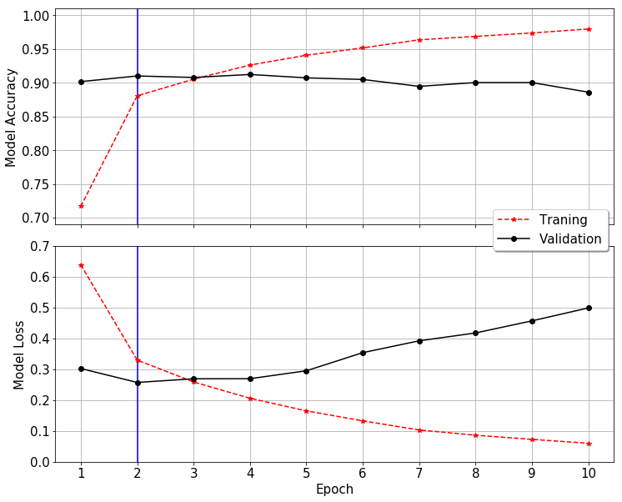

Figure 7.3 1D covnet model training and validation scores
Code Section 7.1 Fitting 1D covnets on training and validation data
Train on 15000 samples, validate on 5000 samples
Epoch 1/10
- 13s - loss: 0.6389 - acc: 0.7167 - val_loss: 0.3025 - val_acc: 0.9016
Epoch 2/10
- 12s - loss: 0.3299 - acc: 0.8805 - val_loss: 0.2574 - val_acc: 0.9100
Epoch 3/10
- 12s - loss: 0.2590 - acc: 0.9052 - val_loss: 0.2692 - val_acc: 0.9078
Epoch 4/10
- 12s - loss: 0.2061 - acc: 0.9261 - val_loss: 0.2695 - val_acc: 0.9122
Epoch 5/10
- 12s - loss: 0.1652 - acc: 0.9407 - val_loss: 0.2952 - val_acc: 0.9072
Epoch 6/10
- 12s - loss: 0.1329 - acc: 0.9516 - val_loss: 0.3540 - val_acc: 0.9048
Epoch 7/10
- 12s - loss: 0.1032 - acc: 0.9636 - val_loss: 0.3924 - val_acc: 0.8946
Epoch 8/10
- 12s - loss: 0.0863 - acc: 0.9687 - val_loss: 0.4178 - val_acc: 0.9002
Epoch 9/10
- 12s - loss: 0.0727 - acc: 0.9737 - val_loss: 0.4571 - val_acc: 0.9002
Epoch 10/10
- 12s - loss: 0.0601 - acc: 0.9797 - val_loss: 0.4989 - val_acc: 0.8860
Code Section 7.2 1D covnet model summary
Layer (type) Output Shape Param #
=================================================================
embedding_1 (Embedding) (None, 26, 300) 5549400
_________________________________________________________________
conv1d_1 (Conv1D) (None, 25, 128) 76928
_________________________________________________________________
max_pooling1d_1 (MaxPooling1 (None, 12, 128) 0
_________________________________________________________________
dropout_1 (Dropout) (None, 12, 128) 0
_________________________________________________________________
conv1d_2 (Conv1D) (None, 11, 64) 16448
_________________________________________________________________
max_pooling1d_2 (MaxPooling1 (None, 5, 64) 0
_________________________________________________________________
conv1d_3 (Conv1D) (None, 2, 32) 8224
_________________________________________________________________
max_pooling1d_3 (MaxPooling1 (None, 1, 32) 0
_________________________________________________________________
flatten_1 (Flatten) (None, 32) 0
_________________________________________________________________
dense_1 (Dense) (None, 10) 330
_________________________________________________________________
dense_2 (Dense) (None, 3) 33
=================================================================
Total params: 5,651,363, Trainable params: 5,651,363, Non-trainable params: 0
Table 7.1 Classification report of 1D covnets
 | PR_AUC | F1-SCORE | PRECISION | RECALL
Hate | 0.3362 | 0.3900 | 0.5303 | 0.3084
Offensive | 0.9820 | 0.9476 | 0.9338 | 0.9619
Neutral | 0.8943 | 0.8357 | 0.8465 | 0.8252
Micro Avg | 0.9610 | 0.9093 | 0.9093 | 0.9093
Macro Avg | 0.7375 | 0.7244 | 0.7702 | 0.6985
Weighted Avg | 0.9375 | 0.9035 | 0.9009 | 0.9093
Samples Avg | 0.9521 | 0.9093 | 0.9093 | 0.909
Figure 7.4 Final CNN architecture for tweet classification
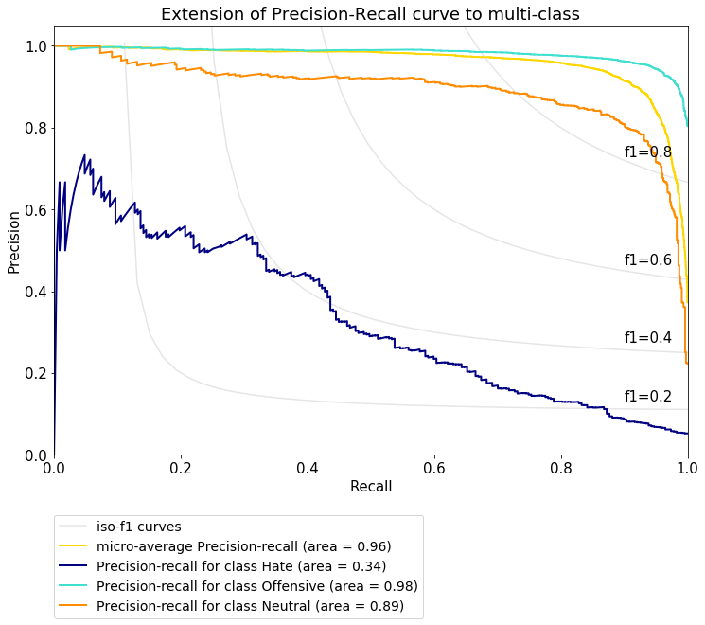
Figure 7.5 Precision-recall curve for 1D covnets
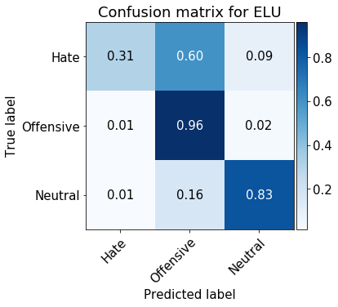
Figure 7.6 Confusion matrix comparing 1D covnet predictions to the true labels

Recurrent Neural Networks
Text data is similar to a time series where information is gathered sequentially at each time step, and the order of time steps is crucial. MLP and CNNs do not treat the text data explicitly as a sequence. Recurrent Neural Networks (RNNs) are a special class of the neural networks developed to process the input data as a sequence and retain the information learned during each step. Figure 8.1 shows a simple recurrent neural network. At any step t, the activation unit receives two inputs:
- token ($x_{i}^{t}$) in the text sequence, and
- activation unit-output from the previous ${(t-1)}^{th}$ step ($a^{t}$).
The affine function of inputs, weights, and biases from previous steps ($W_{aa},W_{ax},b_{a}$) are transformed using non-linear activation functions (f). For the very first input, the activation unit ( $a^{0}$) is an array of zeros. The entire process expressed in one equation,
$$a^{t}=f\left(W_{aa}a^{t}+W_{ax}x_{i}^{t}+b_{a}\right)$$
For the multi-class classification problems, the last unit usually has one more non-linear activation unit (e.g., softmax function). For each data point error between the predicted and true labels is computed. The total loss (cross-entropy loss) per input sequence is minimized by updating the weights and biases using backpropagation through time,
$$J\left(y_{i},{\hat{y}}_{i}\right)=-\sum_{i=1}^{C}{y_{i}\ln{{\hat{y}}_{i}}}→\frac{∂J\left(y_{i},{\hat{y}}_{i}\right)}{∂W}$$
Figure 8.1 Simple Recurrent Neural Network (step t)

Gated Recurrent Unit (GRU)
A deep RNN struggles in terms of the long-term dependencies. If the input tweet sequence is long, the information between the outer most layers of a deep RNN gets lost in the process. The cell memory shared between the two units closer in the sequence is more abundant than those further apart. In the deep networks, the gradient of error could vanish before the weights near the earlier hidden layers
could be updated, defined as the vanishing gradient problem.
Long-Short Term Memory (LSTM) networks were developed to capture the long-range dependencies in the sequence data [12]. A simplified version of LSTM called Gated Recurrent Unit (GRU) addresses the issue of vanishing gradient using network gates [13]. Gates are the parameters that relate the information flow between the units. The gates in RNNs are based on the sigmoid function ($σ\left(x\right)$):
$$Update Gate→ Γ_{u}=σ\left(W_{ua}a^{t-1}+W_{ux}x_{i}^{t}+b_{u}\right)$$
$$Relevance Gate→ Γ_{r}=σ\left(W_{ra}a^{t-1}+W_{rx}x_{i}^{t}+b_{r}\right)$$
The update gate controls how much of the past information should be updated based on the current state of the unit. The relevance gate decides if previous memory information has any relevance to the current or the future layers of the network. In a GRU, the cell memory and the activation unit's output is the same.
Figure 8.2 shows a GRU with steps highlighted below:
- At any step t, a GRU receives two inputs:
  - Value of text sequence at the current time step $t, x_{i}^{t}$, and
  - Cell memory from the previous activation unit, $c^{t-1}\left(=a^{t-1}\right)$
- The relevance gate first processes the information to computes Γr, which updates (elementwise) the activation output of the prior unit ($Γ_{r}*a^{t-1}$).
- An update (suggested) to cell memory is computed, $c_{new}^{t}=\tanh\left(W_{ca}\left[Γ_{r}*a^{t-1}\right]+W_{cx}x_{i}^{t}+b_{c}\right)$.
- Update gate ($Γ_{u}$) is computed separately. It combines the suggested cell memory ($c_{new}^{t}$) and cell memory at the previous step ($c^{t-1}$), to calculate the cell memory at time step t, $c^{t}=Γ_{u}*c_{new}^{t}+\left(1-Γ_{u}\right)*c^{t-1}$.
Figure 8.2 Gated Recurrent Unit
Figure 8.3 Long-Short Term Memory Unit

Long-Short Term Memory Unit (LSTM)
GRUs are simplified versions of LSTMs. LSTMs have two additional gates:
$$Forget Gate→ Γ_{f}=σ\left(W_{fa}a^{t-1}+W_{fx}x_{i}^{t}+b_{f}\right)$$
$$Output Gate→ Γ_{o}=σ\left(W_{oa}a^{t-1}+W_{ox}x_{i}^{t}+b_{o}\right)$$
The forget gate decides whether to delete the current cell memory. The output gate filters the amount of information revealed from the current memory cell to the next one. Unlike GRUs, $c^{t}$ and $a^{t}$ are not equal in LSTMs. Figure 8.3 shows an LSTM unit with its steps discussed below:
- The LSTM unit receives three different inputs:
  - Value of text sequence at the current time step $t, x_{i}^{t}$.
  - Cell memory computed at the previous step, $c^{t-1}$.
  - Activation unit output at the previous time step, $a^{t-1}$.
- The information passes through the relevance gate that computes $Γ_{r}$, which updates (elementwise) the activation unit output from the previous step ($Γ_{r}*a^{t-1}$).
- An update (suggested) to cell memory is computed as, $c_{new}^{t}=\tanh\left(W_{ca}\left[Γ_{r}*a^{t-1}\right]+W_{cx}x_{i}^{t}+b_{c}\right)$.
- Update gate ($Γ_{u}$) and forget gate ($Γ_{f}$) are computed to combine the suggested cell memory ($c_{new}^{t}$) and cell memory from the previous step ($c^{t-1}$), and to calculate the cell memory at step t, $c^{t}=Γ_{u}*c_{new}^{t}+Γ_{f}*c^{t-1}$
- The LSTM unit has two separate outputs: the cell memory ($c^{t}$) and the filtered version called the activation output, $a^{t}=Γ_{o}*c^{t}$.

Tweet Classification using LSTM
A neural network: dropout layer→LSTM layer→flat layer→dense layer→output layer, was trained using the training and validation set. Figure 8.4 shows the training and validation set accuracy and loss plots, and Code Section 8.1 shows the model training history per epoch. Minimum validation loss of 25% and corresponding validation accuracy of about 91% was observed at epoch 4. After the 4th epoch, the LSTM model started to overfit on the training data. Based on this model, the architecture shown in Figure 8.5 was selected. Code Section 8.2 shows the input and output dimensions of each layer, along with the total number of training parameters.
The LSTM model outperformed all other models in term of performance measures, PR curve, and confusion matrix. The micro average precision score of LSTM model was the same as the 1D covnets; however, had higher per-class values (Figure 8.6). From Figure 8.7, the model correctly labeled 37% and 95% of hate and offensive tweet and was also able to assign the correct class to the neutral tweets relative to the other neural network models.
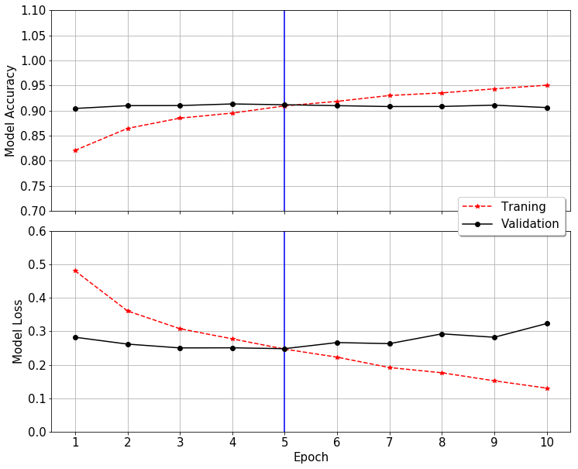

Figure 8.4 LSTM model training and validation scores

Code Section 8.1 LSTM Model fit on training and validation data
Train on 15000 samples, validate on 5000 samples
Epoch 1/10
- 36s - loss: 0.4809 - acc: 0.8207 - val_loss: 0.2823 - val_acc: 0.9042
Epoch 2/10
- 35s - loss: 0.3610 - acc: 0.8645 - val_loss: 0.2618 - val_acc: 0.9098
Epoch 3/10
- 36s - loss: 0.3078 - acc: 0.8849 - val_loss: 0.2503 - val_acc: 0.9100
Epoch 4/10
- 35s - loss: 0.2774 - acc: 0.8950 - val_loss: 0.2507 - val_acc: 0.9132
Epoch 5/10
- 35s - loss: 0.2467 - acc: 0.9093 - val_loss: 0.2481 - val_acc: 0.9116
Epoch 6/10
- 35s - loss: 0.2227 - acc: 0.9183 - val_loss: 0.2663 - val_acc: 0.9098
Epoch 7/10
- 35s - loss: 0.1917 - acc: 0.9301 - val_loss: 0.2631 - val_acc: 0.9080
Epoch 8/10
- 35s - loss: 0.1760 - acc: 0.9353 - val_loss: 0.2924 - val_acc: 0.9082
Epoch 9/10
- 35s - loss: 0.1520 - acc: 0.9433 - val_loss: 0.2822 - val_acc: 0.9108
Epoch 10/10
- 36s - loss: 0.1302 - acc: 0.9505 - val_loss: 0.3232 - val_acc: 0.9060

Code Section 8.2 LSTM Model summary
Layer (type) Output Shape Param #
=================================================================
embedding_1 (Embedding) (None, 26, 300) 5549400
_________________________________________________________________
spatial_dropout1d_1 (Spatial (None, 26, 300) 0
_________________________________________________________________
lstm_1 (LSTM) (None, 26, 300) 721200
_________________________________________________________________
flatten_1 (Flatten) (None, 7800) 0
_________________________________________________________________
dense_1 (Dense) (None, 3) 23403
=================================================================
Total params: 6,294,003, Trainable params: 6,294,003, Non-trainable params: 0

Figure 8.5 LSTM model architecture for tweet classification
Table 8.1 Classification report of LSTM model fit on test day
 | PR_AUC | F1-SCORE | PRECISION | RECALL
Hate | 0.382469 | 0.404878 | 0.453552 | 0.365639
Offensive | 0.983171 | 0.949375 | 0.949001 | 0.949750
Neutral | 0.915308 | 0.865248 | 0.842965 | 0.888742
Micro Avg | 0.963747 | 0.912398 | 0.912398 | 0.912398
Macro Avg | 0.760316 | 0.739834 | 0.748506 | 0.734710
Weighted Avg | 0.943949 | 0.910254 | 0.908749 | 0.912398
Samples Avg | 0.953760 | 0.912398 | 0.912398 | 0.912398

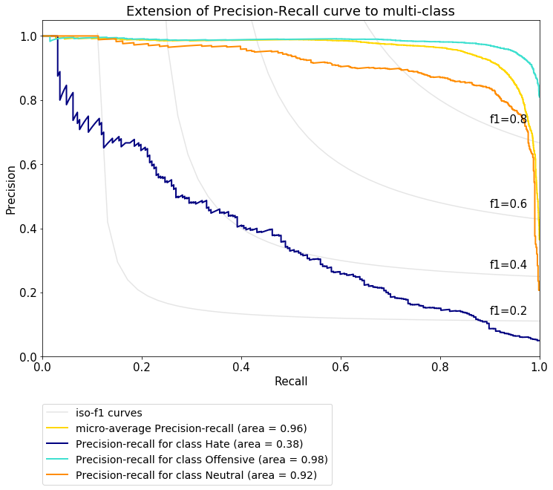
Figure 8.6 Precision-Recall curve for the LSTM model
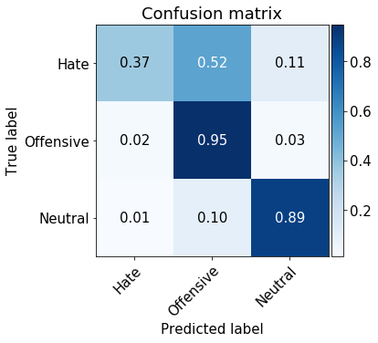
Figure 8.7 Confusion matrix of LSTM test predictions

Summary
This study evaluated the performance of the different machine learning algorithm on multiclass classification using Twitter dataset. Tweets in the dataset had three different classes: hate (label 0), offensive (label 1) and neutral (label 2) class. The dataset was highly imbalanced with 6%, 77%, and 17% tweets in the hate, offensive, and neutral class, respectively. The dataset was split into train-validation-test set. Performance of the random forests was evaluated on eight different inputs: character and word n-grams. The model performed best on the character level, but for comparison with neural networks, random forest with word unigrams was selected as the baseline model. Due to data class imbalance, micro-average F1-score, micro-average precision score (area under the precision-recall curve) and confusion matrix were compared simultaneously to compare different classifiers, with priority given the confusion matrix in case of a tie because the focus of the study to develop classifiers that can filter harmful speech than to classify neutral tweets. Table 9.1 and Table 9.2 compares the three performance measures of each classifier. LSTM outperformed other models in terms of micro-average precision and f1-score, as shown in Figure 9.2. LSTM was also able to have a higher count of true positives for hate class about 36%, 21% and 19% more than the random forest, MLP and 1D covnets, respectively (Figure 9.1). Overall the neural network models performed relatively better than the random forest model suggesting their ability to classify imbalanced class data better than random forests.
Table 9.1 Confusion matrices of four classifiers on test data
 |  | Random Forest  PREDICTIONS |  |  | MLP  PREDICTIONS |  |  | 1D Covnets  PREDICTIONS |  |  | LSTM  PREDICTIONS
 |  | 0 | 1 | 2 | 0 | 1 | 2 | 0 | 1 | 2 | 0 | 1 | 2
TRUE LABELS | 0 | 61 | 127 | 39 | 69 | 132 | 26 | 70 | 137 | 20 | 83 | 119 | 25
TRUE LABELS | 1 | 57 | 3556 | 188 | 89 | 3599 | 113 | 52 | 3656 | 93 | 91 | 3610 | 100
TRUE LABELS | 2 | 6 | 53 | 696 | 19 | 161 | 575 | 10 | 122 | 623 | 9 | 75 | 671
 |  | 0 → Hate Class, 1 → Offensive Class, 2 → Neutral Class
Table 9.2 Comparison of average precision and F1-score of four classifiers
 | Model | Average Precision Score | F1-Sore
Micro Avg | Random Forests | 0.9412 | 0.9032
Micro Avg | Multilayer Perceptron | 0.9461 | 0.8871
Micro Avg | 1D Convolution Networks | 0.9610 | 0.9093
Micro Avg | Long-Short Term Memory Networks | 0.9638 | 0.9124

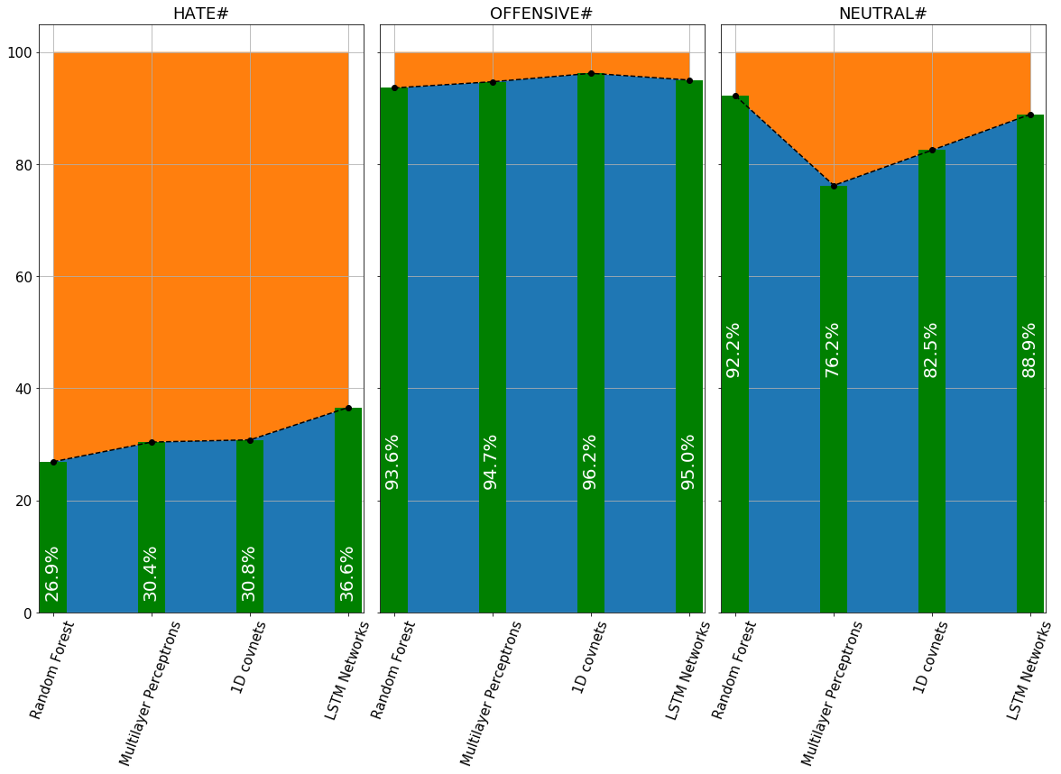
Figure 9.1 Comparison of percentage of true postives per class per classifier

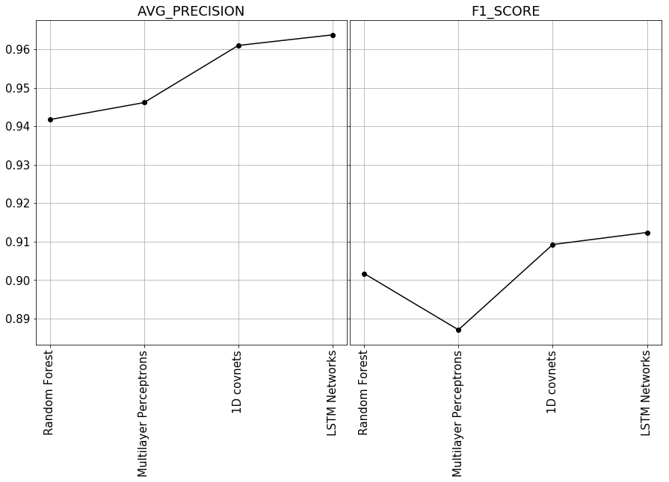
Figure 9.2 Comparison of micro-average precision and f1-score
Bibliography

[1] | "An empirical evaluation of supervised learning in high dimensions," in 25th International Conference on Machine Learning, Helsinki, Finland, 2008.
[2] | C. O. D. Archives, "Hate Speech Identification," 2016. [Online]. Available: https://data.world/crowdflower/hate-speech-identification.
[3] | T. Davidson, D. Warmsley, M. Macy and I. Weber, "Automated Hate Speech Detection and the Problem of Offensive Language," in Proceedings of the 11th International Conference on Web and Social Media (ICWSM), Montreal, 2017.
[4] | Z. Harris, "Distributional Structure," WORD, vol. 10, no. 23, pp. 146-162, 1954.
[5] | S. Deerwester, S. Dumais, G. Furnas, T. Landauer and R. Harshman, "Indexing by Latent Semantic Analysis," Journal of the American Society for Information Science, vol. 41, pp. 391-407, 1990.
[6] | G. Salton, A. Wong and C.-S. Yang, "A vector space model for automatic indexing," Communications of ACM, vol. 18, no. 11, pp. 613-620, 1975.
[7] | T. Mikolov, I. Sutskever, K. Chen, G. Corrado and J. Dean, "Distributed Representation of Words and Phrases and their Compositionality," 2013.
[8] | J. Pennington, R. Socher and C. D. Manning, "GloVe: Global Vectors for Word Representation," in Conference on Empirical Methods in Natural Language Processing, Doha, 2014.
[9] | S. Arora, Y. Li, Y. Liang, T. Ma and A. Risteski, "A Latent Variable Model Approach to PMI-based Word Embeddings," Transactions of the Association for Computational Linguistics, pp. 385-399, 2016.
[10] | S. Malmasi and M. Zampieri, "Detecting Hate Speech in Social Media," in Proceedings of Recent Advances in Natural Language Processing, Varna, Bulgaria, 2017.
[11] | "Convolution," 2019. [Online]. Available: https://en.wikipedia.org/wiki/Convolution.
[12] | S. Hochreiter and J. Schmidhuber, "Long Short-term Memory," Neural Computation, pp. 1735-1780, 1997.
[13] | K. Cho, B. v. Merrienboer, D. Bahdanau and Y. Bengio, "On the Properties of Neural Machine Translation: Encoder-Decoder Approaches," arXiv.org, 03 Sept 2014.
[14] | Wikipedia, "n-gram," 02 2011. [Online]. Available: https://en.wikipedia.org/wiki/N-gram. [Accessed July 2019].
[15] | G. James, D. Witten, T. Hastie and R. Tibshirani, An Introduction to Statistical Learning with Applications in R, Springer Publishing Company, 2014.
[16] | T. Whitlock, "Emoji Unicode Tables," 2019.
[17] | S. Malmasi and M. Zampieri, "Detecting Hate Speech in Social Media," in Proceedings of Recent Advances in Natural Language Processing, Varna, Bulgaria, 2017.
[18] | K. &. Z. A. Simonyan, "Very Deep Convolutional Networks for Large-Scale Visual Recognition," 2014. [Online]. Available: http://www.robots.ox.ac.uk/~vgg/research/very_deep/.
[19] | K. K. S. C. A. &. A. A. Gopalakrishnan, "Deep Convolutional Neural Networks with transfer learning for computer vision-based data-driven pavement distress," Construction and Building Material, vol. 157, pp. 322-330, 2017.

